CrossFit Bytown Steps

Download our app at [http://register.bytown.fit](https://can01.safelinks.protection.outlook.com/?url=http%3A%2F%2Fregister.bytown.fit%2F&data=05%7C02%7Caudrey.d.taylor%40servicecanada.gc.ca%7C4fb175bdbb284597034808dc1abc962f%7C9ed558468a814246acd8b1a01abfc0d1%7C0%7C0%7C638414644503270956%7CUnknown%7CTWFpbGZsb3d8eyJWIjoiMC4wLjAwMDAiLCJQIjoiV2luMzIiLCJBTiI6Ik1haWwiLCJXVCI6Mn0%3D%7C3000%7C%7C%7C&sdata=jKY08yNRIChB41DwtQ5vWSQtkhIl3%2BM8c6ueQDW3hbs%3D&reserved=0)  
Use the code Q5B3RD to get access  
Create an account to login. You can use your Google or Facebook account.

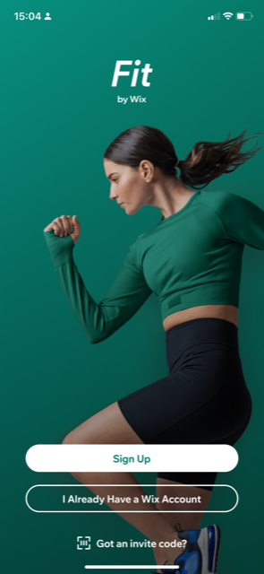

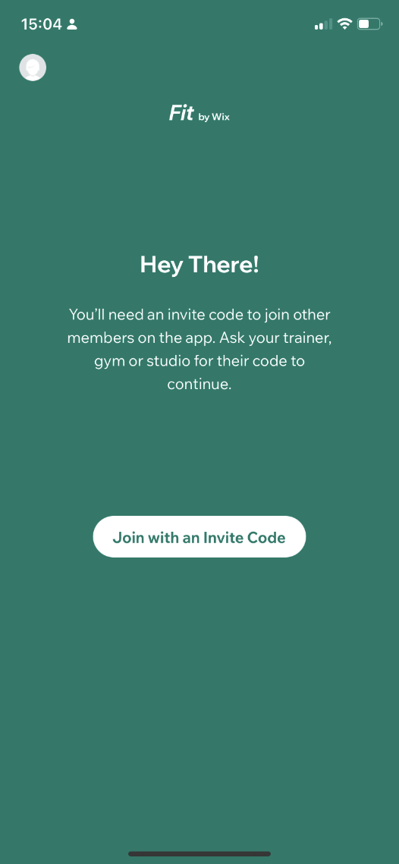

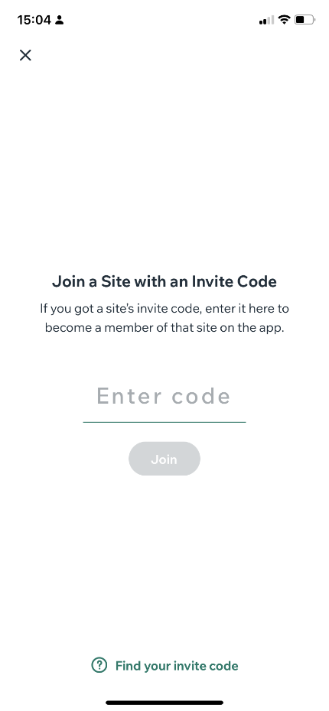

*This is where you input the Access code: Q5B3RD

The request will be sent to Everett (the Owner)- he will accept (check your email) and then you will have access to CrossFit Bytown on the Fit App:

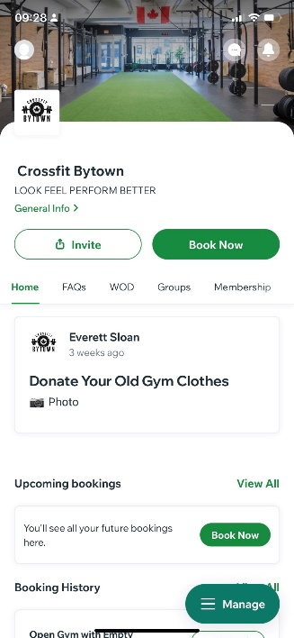

Now go to schedule to select “Unbroken Recovery”

The evenings we are at Bytown are: Tuesday, 7:00pm

Thursday, 7:00pm and Friday, 6:30pm.

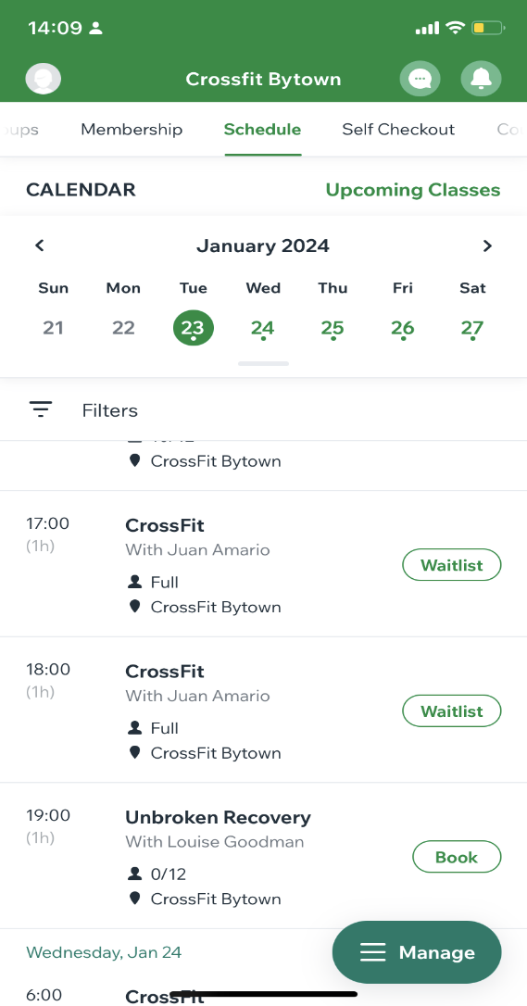

One you click “Book” it will prompt for a payment option, this is automatically generated by the app. Since we are separate from the Bytown classes and run off our own donation Process, simply hit “Pay in Person” – and you are successfully registered 😊

