NCR Process

Check out this Video – also below are step by step instructions 😊



1. To create an account, go to: [www.crossfitncr.ca](http://www.crossfitncr.ca) & select Kaladar.

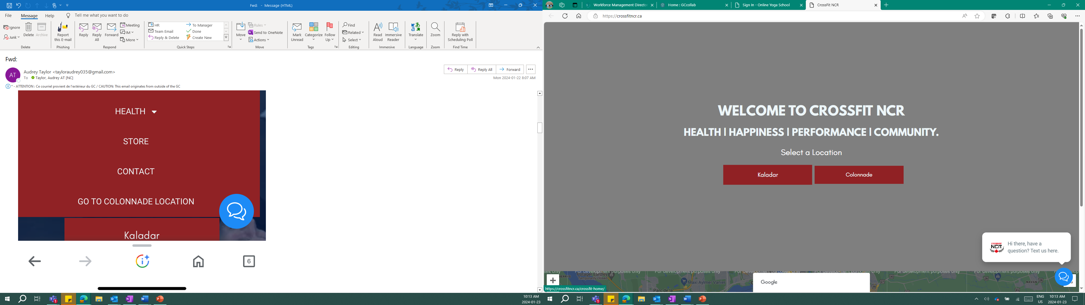

1. Hit Join – Memberships!

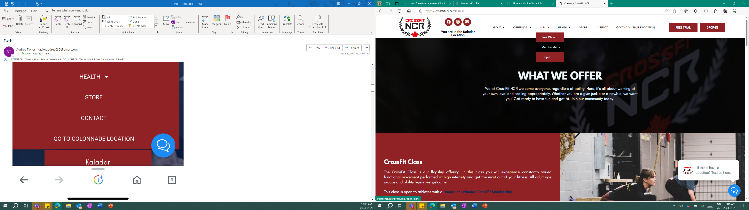

3. Click on “Unbroken Recovery” CA 0.00$

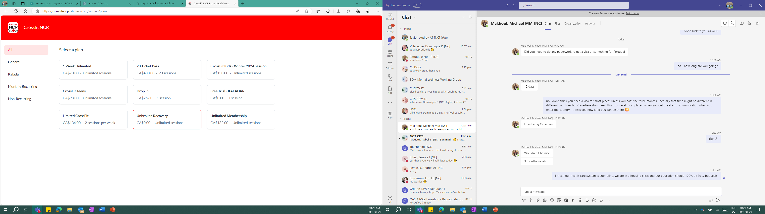

4.Enter your email

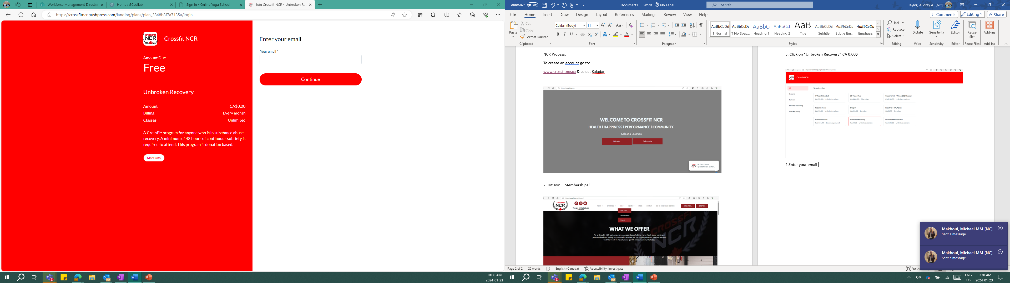

1. Create an account. You can now check your email for access instructions!

You can register for the classes online using this website and process.

Once your account is created, you can download the Push Press App and sign in and book class.

